

Documentation on

**“LIFESTREAM BLOOD BANK”**

e-DAC May 2021

**Guided By:** Bakul Joshi

**Submitted By: Group no 09**

Jyotika Sable 210543081037

Jayshri Kathore 210543081041

Kedar Beedkar 210543081044

Shaikh Nahid 210543081096

**Table of Contents**

**1. Introduction 4**

1.1 Document Purpose **4**

1.2 Project Background **4**

1.3 Aim & Objectives **4**

**2. Business Requirements Overview**…………………………………………………………………………………**5**

**3.Functional Requirements** **6**

3.1 Donor Module **6**

3.2 Hospital Module **6**

3.3 Admin Module **6**

**4.** **Non-Functional Requirement…………………………………………………………...…7**

**5. Use Case Diagram 8**

5.1 Admin **9**

5.2 Donor **10**

5.3 Hospital **11**

**6. Database Design 12**

1 User **12**

2 Security Question **12**

3 Hospital………………………………………………………………………………… **13**

4 Donor **13**

5 Blood bank **13**

6 Blood stock **13**

7 Blood Request **13**

8 Blood Group id **13**

9 Request Donor **14**

**7. E-R Diagram……………………………………………………………………...………14**

**8. Snapshots 15**

**9. Conclusion 20**

**List of Figures**

**Use Case Diagrams 17**

Fig 1 Admin 8

Fig 2 Donor 9

Fig 3 Hospital 10

Fig 4 ER Diagram 14

**1.Introduction**

**1.1 Document Purpose**

This document communicates the business requirements and scope for developing LifeStream Blood Bank. The scope of this document is to define the functional and non- functional requirements, business rules and other constraints requirements.

**1.2 Project Background**

There is no computerized system for the blood donation. Currently, the receiver of blood goes to nearest hospital or rush everywhere for blood. Today, most medical care depends on a steady supply of blood from donors, as one in seven people entering the hospital need blood. An adequate amount of blood is needed in all health care facilities to meet the urgent need for patients facing trauma and other lifesaving procedures, such as blood transfusions – which saves millions of lives each year. It is difficult to rush and search for blood everywhere at the time of emergency.

**1.3 Aim & Objectives**

The main objective of this project is to build a website which will help people and patients to get the appropriate blood sample and the quantity of blood for medical emergency as early as possible.

Here if suppose some patient needs blood, they can easily register on website and put information on website and they will get the information about blood bank and they can easily collect it. Even hospital can also make request to the portal. As a result, we can save time and make sure blood is available for patient.

**2.Business Requirements Overview**

* LifeStream Blood Bank is the public web application.
* LifeStream Blood Bank will be opened in India, but in the phase 1, the main target is in the Maharashtra.
* There are mainly two types of users. One is the patient and other is blood donor.
* Donors/patients can search for the available blood bank details and information.
* Hospital can search for the blood sample.
* LifeStream Blood Bank provides the functions which connects the hospital and the donor efficiently.
* LifeStream Blood Bank could be maintained by Administrator.

# 3.Functional Requirements Overview

LifeStream Blood Bank consists of four modules described as below.

1. Hospital Module
2. Donor Module
3. Admin Module

# **3.1 Hospital Module**

* Hospital can register, create its own account and login.
* LifeStream Blood Bank provides the function which allows hospital authority to post online request for particular blood group donor.
* Hospital can access request history of blood to check whether the request has been accepted or denied.

# **3.2 Donor Module**

* Donor can register and create his own account.
* LifeStream Blood Bank provides the function which allows donor to select appointment date.
* Donors can see their previous donation history.
* Donor can even request for blood for his/her family.

# **3.3 Admin Module**

* LifeStream Blood Bank should provide all functions to admin how to handle the system.
* The new login or online requests are handled by the admin.
* Could able to know all the information of hospital and donor.
* Status and quantity of blood available.
* Admin even can see the pending requests and full request history.

# 4.Non-functional Requirements

* The website should use professional design, look and feel and color scheme.
* Users will have no limitations for accessing the application through Internet. The portal being an internet application, it is difficult specify exact number of visitor or users. Hence, we will target the system to support between 5 and 10 million users on launch of phase 1.
* Being a public website, the site must follow general usability guidelines for menus, navigations, colors, links and other actions provided on the screens.
* The system should be designed in such a manner that user will be able to complete tasks in minimum number of steps.

**5.Use Case Diagram**

**5.1Admin**



**Admin**

*Fig: Use case diagram of admin*

**5.2Donor**



**Donor**

*Fig: Use case diagram of donor*

**5.3Hospital**



**Hospital**

*Fig: Use case diagram of hospital*

**6.Database Design**

**1] user**

|  |  |  |  |  |  |
| --- | --- | --- | --- | --- | --- |
| **Field** | **Type** | **Null** | **Key** | **Default** | **Description** |
| UID | Integer | No | Primary |  | User ID |
| ROLLID | Integer | No |  |  | Roll ID |
| EMAILID | Varchar(45) | No |  |  | Email ID of USER |
| PASSWORD | Varchar(45) | No |  |  | Password of USER |
| SQUESTIONID | Integer | No |  |  | Security Question |
| ANSWER | Varchar(10) | No |  |  | Answer to the Question |

**2] security_question**

|  |  |  |  |  |  |
| --- | --- | --- | --- | --- | --- |
| **Field** | **Type** | **Null** | **Key** | **Default** | **Description** |
| SQUESTIONID | Integer | No | Primary |  | Id of question |
| SECURITY_QUESTION | Integer | No | Foreign |  | User ID |

**3] hospital**

|  |  |  |  |  |  |
| --- | --- | --- | --- | --- | --- |
| **Field** | **Type** | **Null** | **Key** | **Default** | **Description** |
| HOSPITALID | Integer | No | Primary key |  | Hospital ID |
| UID | Integer | No | Foreign key |  | User ID |
| NAME | Varchar(45) | No |  |  | Hospital Name |
| ADDRESS | Varchar(45) | No |  |  | Address |
| CITY | Varchar(45) | No |  |  | City Name |
| CONTACTNO | Varchar(13) | No |  |  | Contact No |

**4] Donor**

|  |  |  |  |  |  |
| --- | --- | --- | --- | --- | --- |
| **Field** | **Type** | **Null** | **Key** | **Default** | **Description** |
| DONORID | Integer | No | Primary key |  | Donor ID |
| UID | Integer | No | Foreign key |  | User ID |
| BLOODGROUPID | Integer | No | Foreign key |  | Blood Group |
| NAME | Varchar(45) | No |  |  | Donor Name |
| GENDER | Char(1) | No |  |  | Gender Information |
| DOB | Date | No |  |  | Date Of Birth |
| CONTACTNO | Varchar(13) | No |  |  | Contact Number |
| ADDRESS | Varchar(45) | No |  |  | Permanent Address |
| CITY | Varchar(45) | No |  |  | City Name |

**5] Blood_bank**

|  |  |  |  |  |  |
| --- | --- | --- | --- | --- | --- |
| **Field** | **Type** | **Null** | **Key** | **Default** | **Description** |
| BLOODBANKID | Integer | No | Primary |  | Blood bank id |
| UID | Integer | No | Foreign |  | User id |
| NAME | Varchar(40) | No |  |  | Blood bank name |
| ADDRESS | Varchar(50) | No |  |  | Address |
| CITY | Varchar(20) | No |  |  | City |
| CONTACTNO | Varchar(13) | No |  |  | Contact no |
| EMAILID | Varchar(50) | No |  |  | Mail id of bank |

**6] Blood_stock**

|  |  |  |  |  |  |
| --- | --- | --- | --- | --- | --- |
| **Field** | **Type** | **Null** | **Key** | **Default** | **Description** |
| STOCKID | Integer | No | Primary |  | Stock id |
| BLOODGROUPID | Integer | No | Foreign |  | Blood group |
| QUANTITY | Double | No |  |  | Amount of blood |
| DONATION_DATE | Date | No |  |  | Dt of donation |

**7] Blood_Request**

|  |  |  |  |  |  |
| --- | --- | --- | --- | --- | --- |
| **Field** | **Type** | **Null** | **Key** | **Default** | **Description** |
| REQUESTID | Integer | No | Primary |  | Request id |
| UID | Integer | No | Foreign |  | User id |
| BLOODGROUPID | Integer | No | Foreign |  | Blood group |
| PNAME | Varchar(50) | No |  |  | Name of patient |
| REQUEST_DATE | Date | No |  |  | Dt of request |
| QUANTITY | Double | No |  |  | Quantity of blood |
| PADDRESS | Varchar(50) | No |  |  | Address of patient |
| PCONTACTNO | Varchar(13) | No |  |  | Contact no of patient |
| REQUESTSTATUS | Varchar(45) | No |  |  | Status i.e. Approved or Rejected |

**8] BloodGroups**

|  |  |  |  |  |  |
| --- | --- | --- | --- | --- | --- |
| **Field** | **Type** | **Null** | **Key** | **Default** | **Description** |
| BLOODGROUPID | Integer | No | Primary |  | Blood group id |
| BLOODGROUP | Varchar(10) | No |  |  | Blood Group |

**9] Request status**

|  |  |  |  |  |  |
| --- | --- | --- | --- | --- | --- |
| **Field** | **Type** | **Null** | **Key** | **Default** | **Description** |
| REQUESTID | Integer | No | Foreign |  | Request id |
| UID | Integer | No | Foreign |  | Donor id |

**7.ER Diagram**

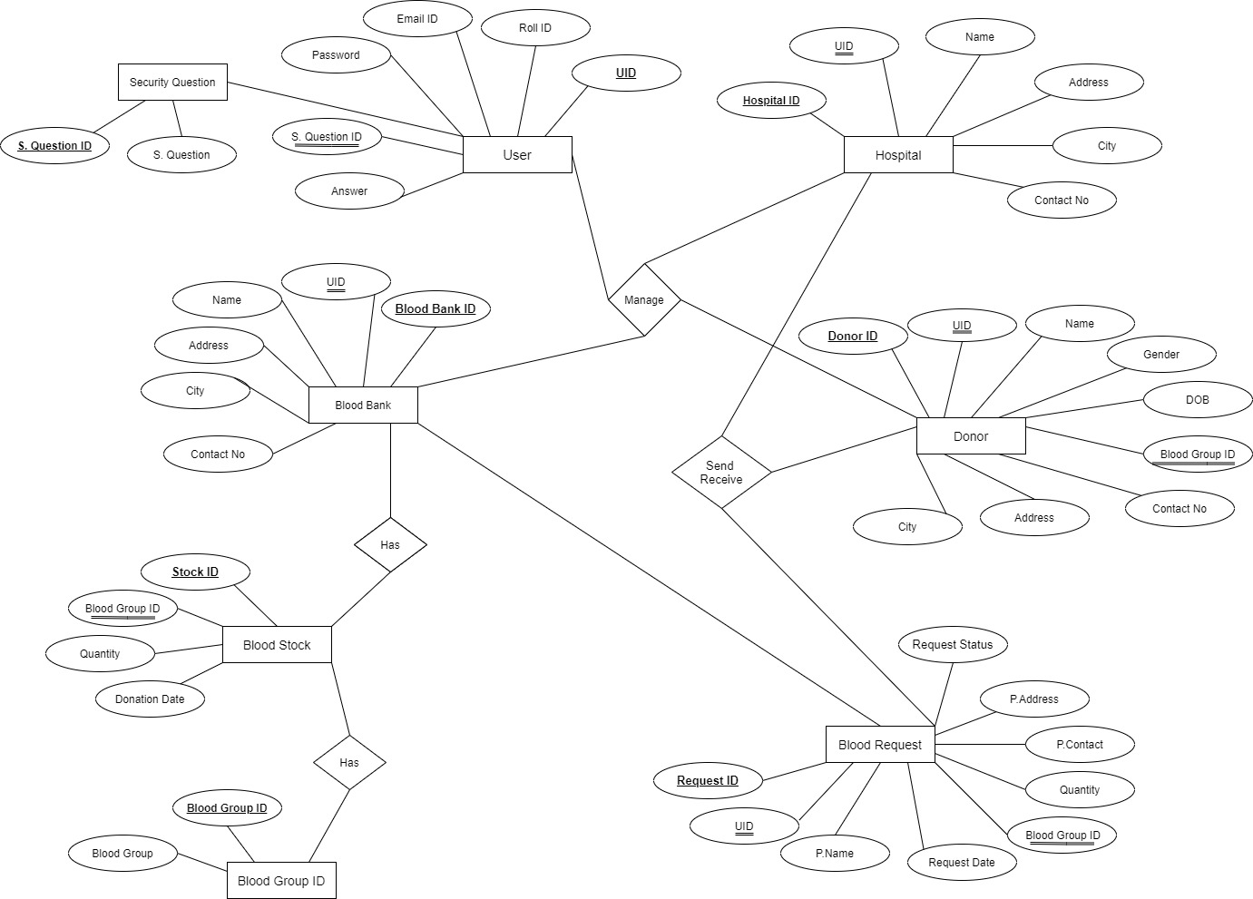

**8.Snapshots**

**8.1Home Page**

Following snapshot shows the home page for Lifestream Blood Bank System

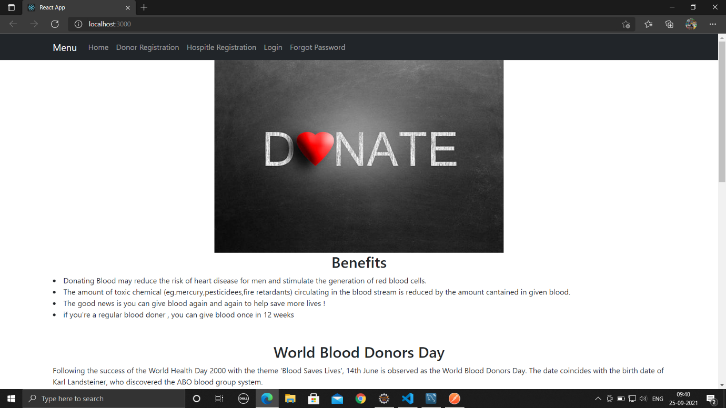

This page contains following controls

* Home
* Eligibility
* Compatibility
* Blood Facts
* Donor Registration
* Login

**8.2 Blood bank Home page**

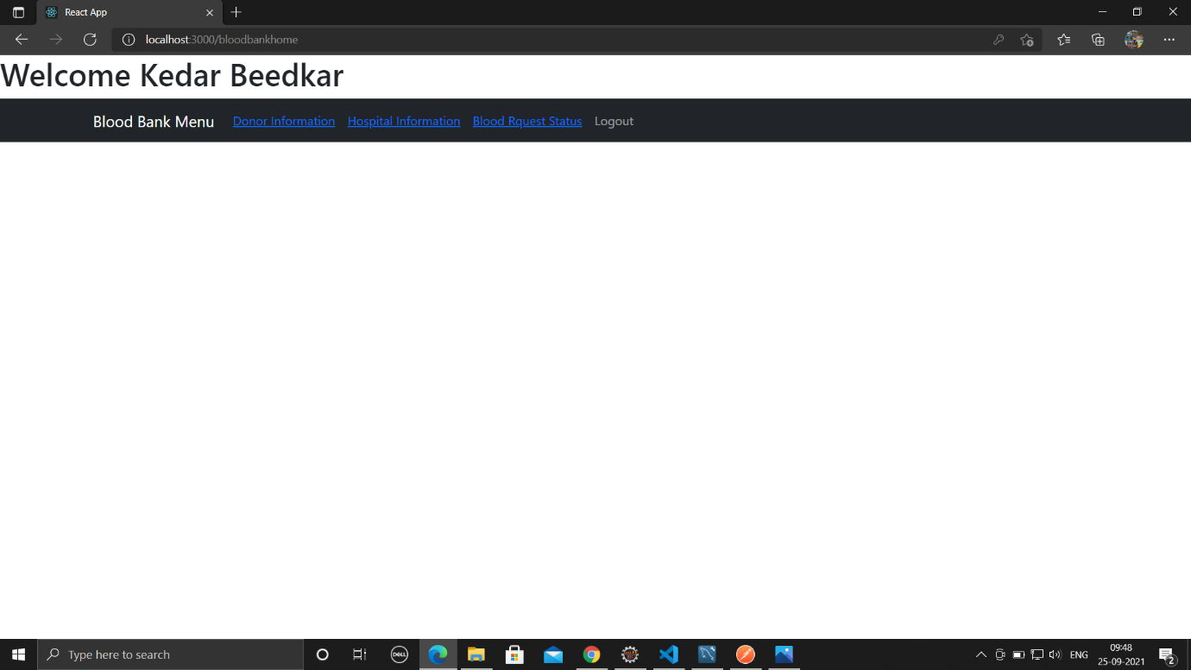

**8.3 Blood Request status**

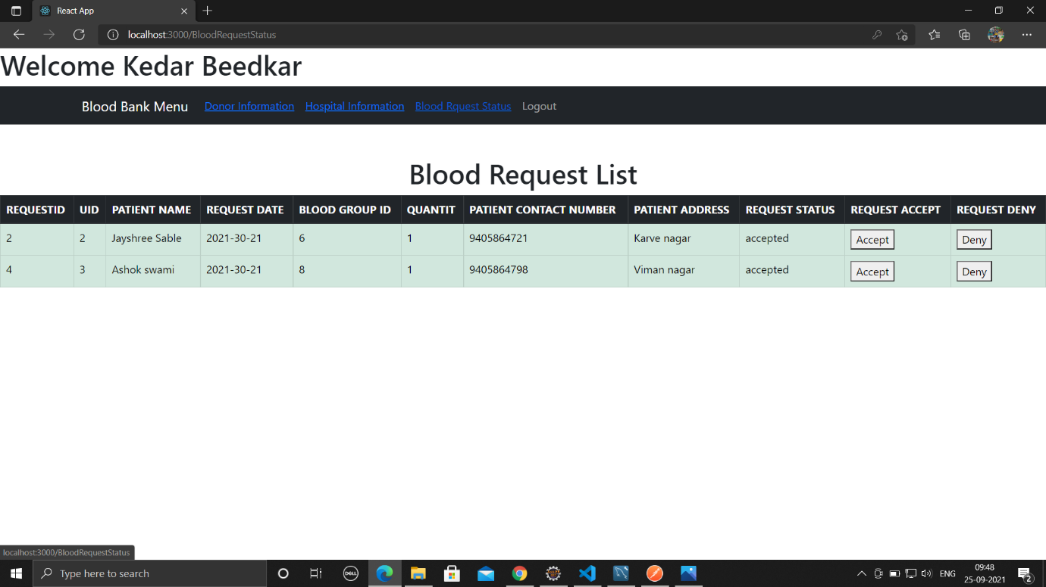

**8.4 Forgot Password**

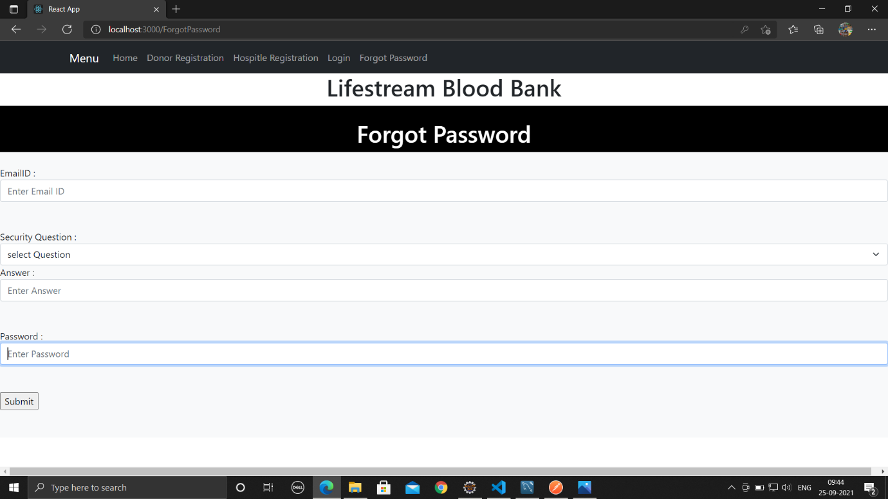

**9.Conclusion & Future Scope**

LifeStream Blood Bank system provides a better platform to receive and donate blood efficiently.

Our system will help people and patients to ger the appropriate blood sample for medical emergency as soon as possible.

Our system provides a very user-friendly platform where needy people can easily get the blood sample by registering on the website, they will also get the information about blood bank. We provide same service for hospital too. When there is an emergency case or when it needs blood, hospital can make a request.